Structured Query langugage

Introduction:
- SQL (Structured Query Language) is a standard language for accessing and manipulating databases.
- SQL commands are used to create, transform and retrieve information for Relation Database Management Systems and also used to create interface between an user and database.
- MySQL is an Open-source and freely available language.

Advantages of SQL:
- Ease of use : It is very easy to learn and use and does not require high-end professional trainning to work upon it.
- Large volume of database can be handled quite easily.
- No Coding required : It is non-procedural and a unified language, ie we need not specify the procefures to accomplish a task but only need to give a command to perform the activity.
- SQL can be linked to most of the other high-level language which make it the first choice for database programmers.
- Protable : It is compatible with other database programs like Dbase IV , Fox Pro , MS Access, MS server, Oracle, Sybase,etc.
- SQL is not case sensitive language ie, both capital and small letter are recognized.

Classification of SQL statements:
SQL statements are classified into following categories:-
In Syllabus | Not in Syllabus
DDL | DCL
DML | TCL
DQL

Data Definition Language (DDL) commands:
- The DDL part of SQL alows database tables to be created or deleted.
- It also defines keys, specifies link between tables and imposes constraints on tables.
- It contains necessary statements for creating, manipulating, altering and deleting the table.
- It let us define the database structure and its related operation.
- Example of DDL commands in SQL are:-
  - Create Database: Creates a new database.
  - USE command: to select and open an already existing database.
  - Show command: to display al the tables in an existing database.
  - Alter Table: modifies the structure of a table.
  - Drop table: deletes a table.

Data Manipulation Language (DML):
- It helps a user to manipulate data.
- The DML statements are executed in the form of queries which are handled by the DML compiler.
- Several DML Commands are:-
  - Insert into statement: To insert new data(record) into a table.
  - Update Statement: to modify or change the data (tuple) in a table (not modifying the data type of column).
  - Delete: To delete dta(tuple) form a table (not deleting a column).

Note: The main difference between DDL and DML is:
DDL is used for the structured of table.
DML is used for the manipulation of data that entered in the table.

Data Query Language (DQL):
- One of the most important tasks when working with SQL is to generate queries and retrieve data.
- A query is a command given to SQL to get a desired(wanted) result from the database table.
- Select command is used to query or retrieve data from a table in the database.
- It is used to retrieve a subset of recordes from one or more tables.

Data Type in SQL:
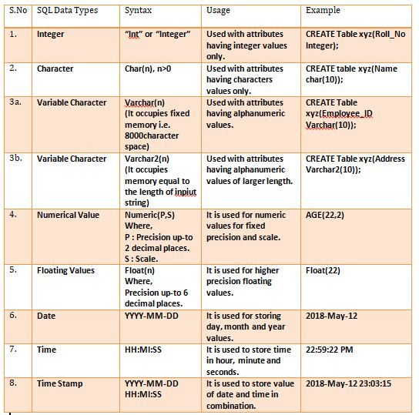

Constraints in SQL:
- Constraints are some set of rules created to apply data validations.
- They ensure accuracy, correctness and reliablity of data.
- It is not compulsory to define constraints to all column of a table it just a optional or condition based require.
Constraints | Description

SQL Commands:
- Keyword : A keyword refers to an individual SQL element that has a special meaning in SQL. EX- SELECT and FROM.
- Clause : A clause is a distinct logical part of an SQL statement. Clauses starts with a keyword for which thay are named and consist of argument as well. EX- SELECT empno, ename FROM employee WHERE salary> 45000;
- Statement : A Statement or command is a combination of two or more clauses. Statement are basically the instruction given to SQL database for executing any task.
EX – SELECT * FROM employee;

Note :- All SQL statements are ends with a semi-colon(;).
DDL Commands:
- Creating Database :
  - The CREATE DATABASE command is used to create a database in RDBMS.
Syntax :- CREATE DATABASE database_name;
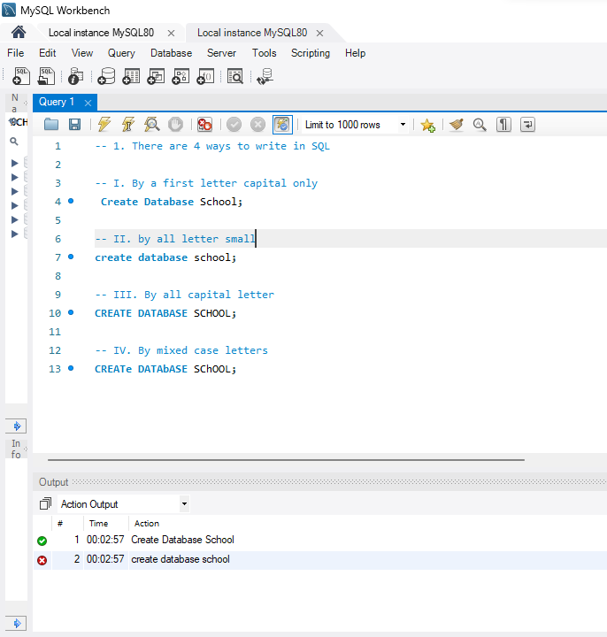
  - Here all the line gives the same result.

- Opening Database :
  - Once a database has been created, we need to open it to work on it, this is done by USE command.
Syntax :- USE database_name;
  - To do futher work in a database we must write this statement at the above of the code.
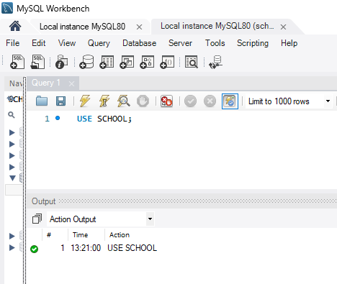

- Removing Database:
  - TO remove/delete a database along with all its tables, DROP DATABASE command is used.
Syntax- DROP DATABASE database_name;
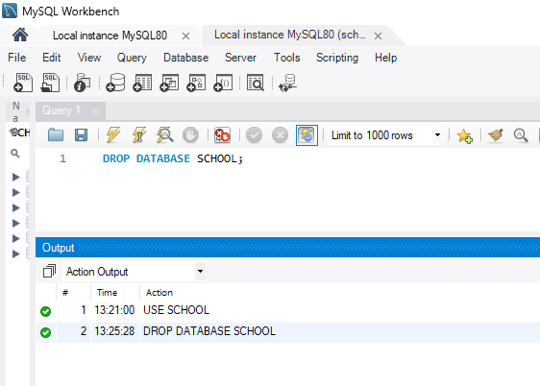

- Creating table :
  - CREATE TABLE statement is used to create a table in a database.
  - Tables are orgnised into rows and columns and each table must have a name.
  - Column defination are separated by comma(,).
Synatx:- CREATE TABLE table_name(
column_name data_type constraints(optional) );
  - UPPER CASE or lower case letters make no difference in column names.
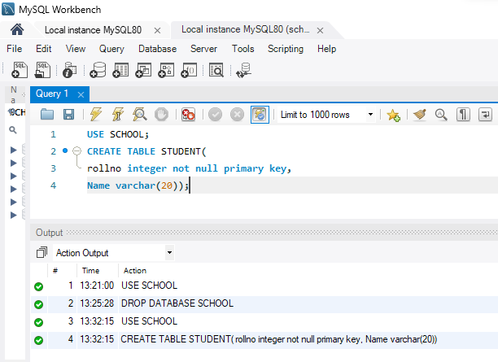

- Viewing a table:
  - To verify that the tables had been created in the database, SHOW TABLES commands is used.
  - It shows all the table name that created in a database.
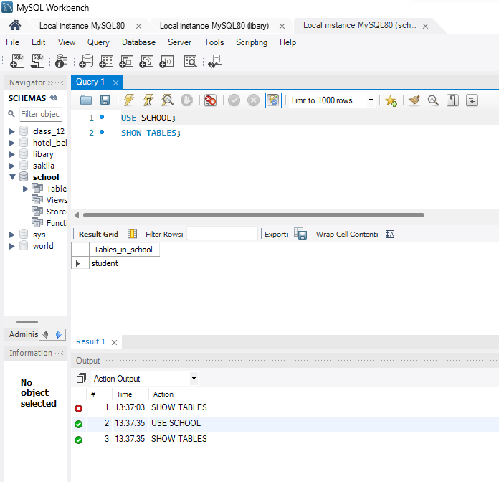

- Viewing a table structure :
  - To shows the structure of the table along with the name of the columns, datatype of the columns and constraints applied on the columns, it is done by DESCRIBE or DESC command.
Syntax:- DESCRIBE table_name; or DESC table_name;
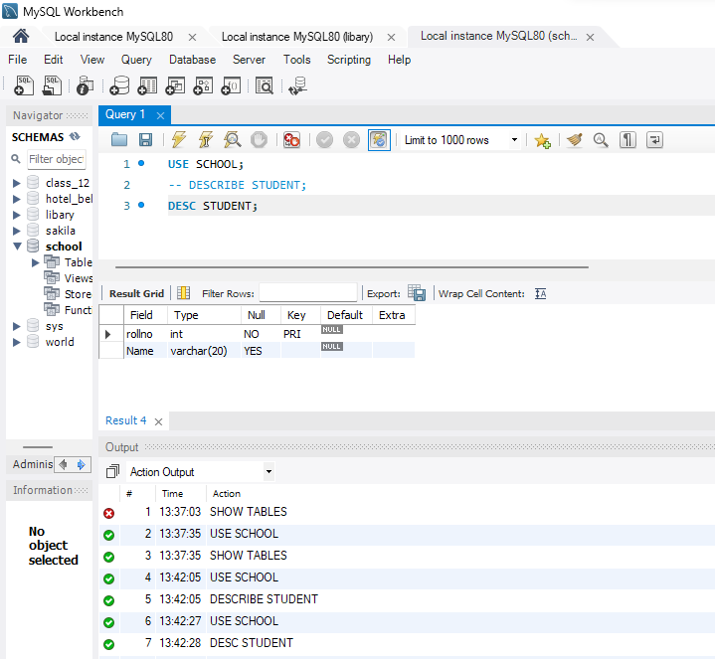

- ALTER TABLE Command:
  - This command is used to modify the structure of a table.
  - This command is used to performed the following operations:
    - To add a column to an existing table.
    - To rename any existing column.
    - To change the data type of any column or changing the size of the datatype.
    - To remove or delete a column of the table.
  - Adding a column to an existing table:-
    - This command only add a new column to the table there is no data present in the newly added column.
Syntax: ALTER TABLE table_name ADD (column_name data_type constraint);
    - This error shows that you can add a column with same only one time.
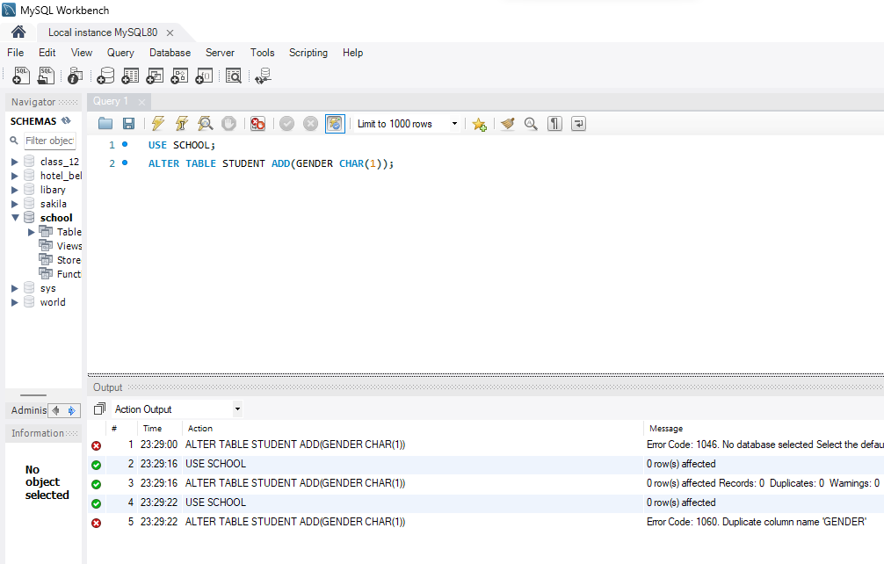

  - Adding a column with default value:-
  - This command is uesd to add a new column to an eisting table with a default value (same for all value ).
  - Futhure you can change this value.
Syntax: ALTER TABLE table_name
ADD ( column_name datatype default data)
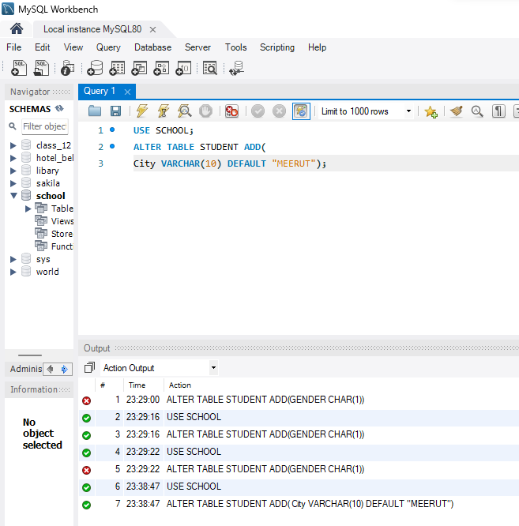
  - Modifying an existing column definiton:-
  - This command is used with ALTER TABLE command to change the datatype, size , constraint of any column of the table.
Syntax: ALTER TABLE table_name
MODIFY column_name datatype ;
  - Here no brackets where used after the MODIFY keyword.
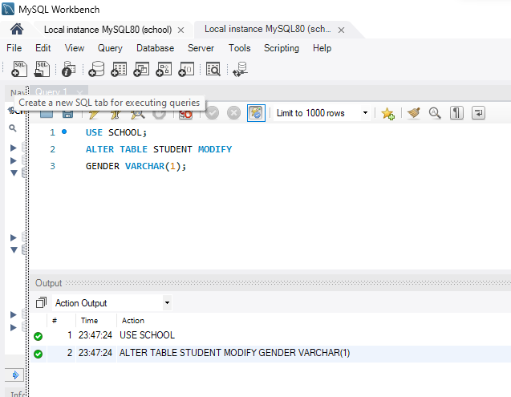

  - Renaming a column:-
  - We can change the name of the column by usign ALTER TABLE command.
Syntax: ALTER TABLE table_name
CHANGE Gender Sex varchar(1);
  - As we know, SQL is not case sensetive so we can write name of column in both uppercase or lowercase.
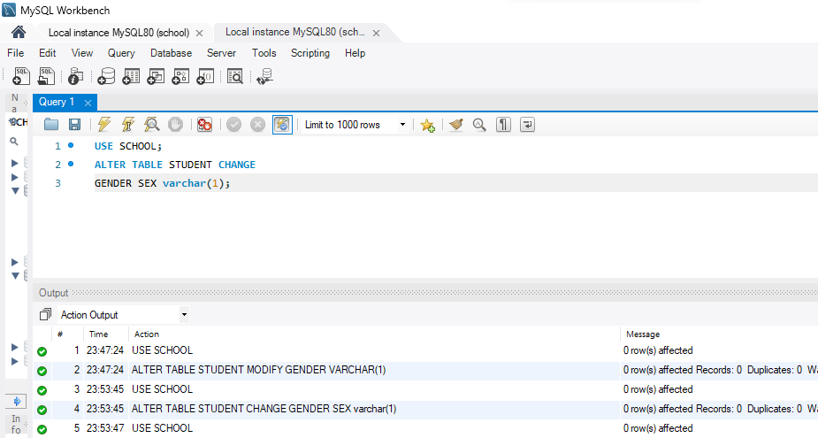

  - Removing a column:-
  - To delete/drop/remove the column in a table we can use ALTER TABLE command.
Syntax: ALTER TABLE table_name DROP column_name;
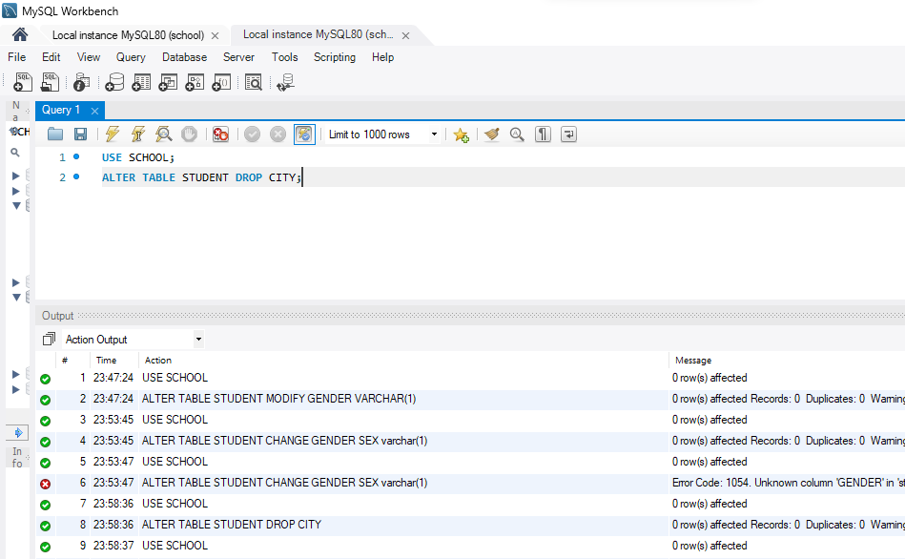
  - Adding and deleting Primay key constraints:-
  - To add or delete a Primary Key constraint even if the table is already been created using Alter table command.
Syntax for adding a Primary key:-
ALTER TABLE table_name ADD PRIMARY KEY (column_name);
  - There is only one primary key in a table.
  - To make a column primary key we must give that column a constraint 'NOT NULL' .
  - If we don't give that column this constraint then SQL give constraint 'NOT NULL' automatically.
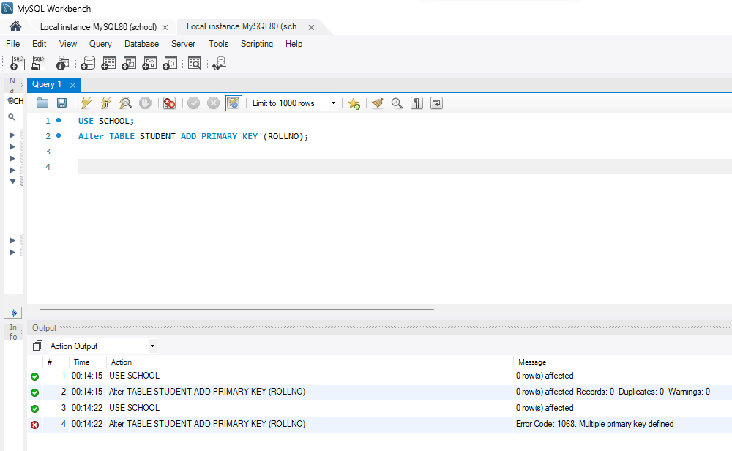
    - Syntax for delete a Primary key constraint from the table:-
ALTER TABLE table_name DROP PRIMARY KEY;

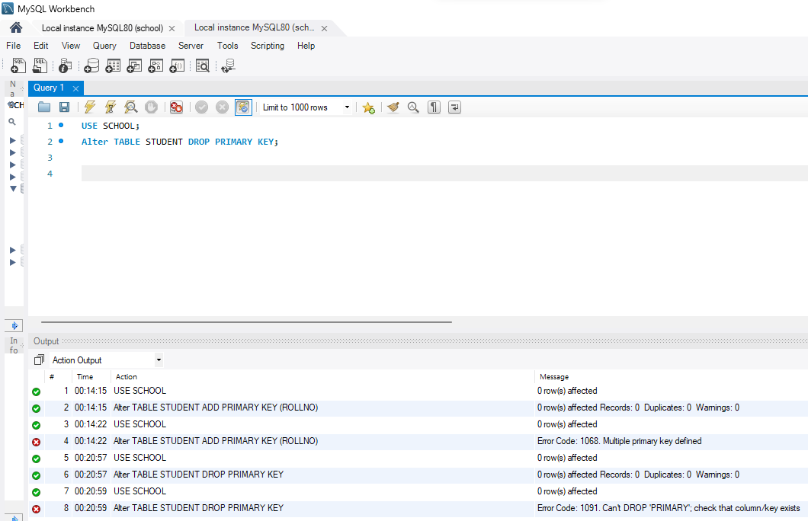
- DROP TABLE Command:
  - To completely destory/remove/delete a table from a database permanently , then we can use DROP TABLE command.
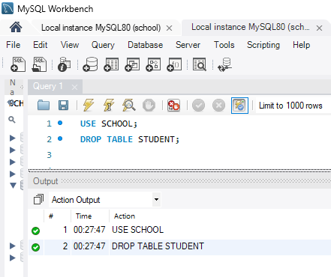
Syntax: DROP TABLE table_name;

DDL Commands:
- Creating Database :
  - The CREATE DATABASE command is used to create a database in RDBMS.

